1-Check whether /user/acadgild directory exists or not in the HDFS.

If it doesn't exist, then create this.

Create a directory /user/acadgild/hadoop.

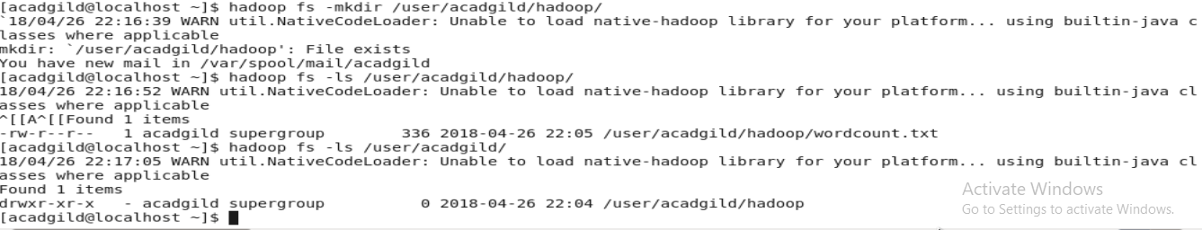

2-Task 2

Create a file in HDFS under directory /user/acadgild/hadoop, with name word-count.txt.

Whatever we type on screen should get appended to the file.

Try to type (on screen) few lines from any online article or textbook.

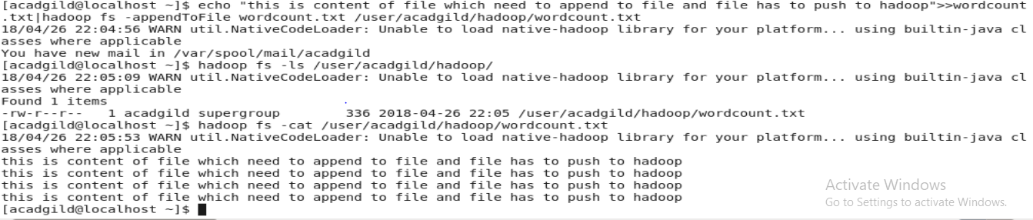

3 and 4- snapshot

Create a file max-temp.txt in local FS.

Put some 10-15 records of date and temperature example:

dd-mm-yyyy,temperature

Example:

10-01-1990,10

10-02-1991,20

Move this file to HDFS at /user/acadgild/hadoop.

Task 4:

Change the permission of the file /user/acadgild/hadoop/max-temp.txt, such that only the owner and

the group members have full control over the file.

Others do not have any control over it.

